Home Rule Party of Hawaii
From Wikipedia, the free encyclopedia
Home Rule Party of Hawaii
Chairperson | Robert William Wilcox
Founded | 6 June 1900
Headquarters | Honolulu, Hawaii
Ideology | Nationalism

As soon as the United States annexed the Hawaiian Islands and established the Territory of Hawaii, native Hawaiians became worried that both the Democratic Party of Hawai‘i and Hawai‘i Republican Party were incapable of representing them. In 1900, native Hawaiians and their supporters created the Hawaiian Independent Party (later renamed the Independent Home Rule Party).

Contents
- 1 Formation
- 2 Legislature
- 3 Decline
- 4 Aloha Aina Party
- 5 References

Formation
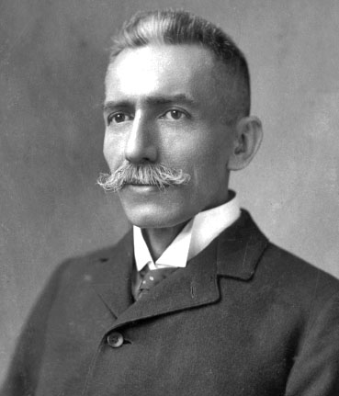
Robert William Wilcox 1900
On June 6, 1900, Robert Wilcox, upon his return from the mainland advocating for native Hawaiian rights in the Organic Act, spoke to a rally sponsored by Hui Aloha ʻĀina and Hui Kalaiʻāina, the two main Hawaiian political clubs. In his speech, he said, "The question of the restoration of the Monarchy is gone from us forever. We are now a people, however, who can vote. You all know we have two-thirds of the votes in this country." He also advised against racial loyalties, saying, "We are all Americans. We should not consider personality." On June 7, 1900, the Hawaiian Independent Party was established, its motto being, "Equal Rights for the People". Despite its motto, and Wilcox's sentiments, it would remain a racially based party.

Legislature
Several members of the House of Kalākaua and House of Kawānanakoa became involved in the party. In the first election in 1900 the ruling Republican Party (formerly the Reform Party) misjudged the voting demographics under the territorialship, though the new government excluded Asians, women, and other minorities, it allowed more people to become eligible voters, swinging the voting majority toward Native Hawaiians. The Home Rule Party succeeded on a nationalist platform in becoming the majority party in the Territorial Senate. In the Territorial House of Representatives, the Home Rule party gained a plurality, but importantly not a majority, of the seats.^{[1]} They sent Robert William Wilcox to represent the territory in the United States Congress. On November 11, 1900, the Independent Home Rule Party was formally established, and the two anti-annexation groups that formed it, Hui Aloha ʻĀina and Hui Kālaiʻāina, were officially dissolved.
As a newly elected delegate from Hawaii, Wilcox proved to be fairly ineffective. On the floor of the United States House of Representatives, Wilcox was challenged by his poor command of the English language, and his lack of alignment with either of the main parties (Democrat and Republican). Although upon his election, he took a more moderate tone, the Home Rule Party proved to be obstructionist and was blamed for a distinct lack of progress in the Territorial legislature. One particular political miscalculation of note was Wilcox's support of the so-called leper bill, which cost him a great deal of support amongst his native Hawaiian base.
The Home Rule Party proved to be ineffective in the Territorial Legislature. During the period that they controlled both chambers of the legislature, chaos ensued.^{[citation needed]} They refused to speak English and debated vehemently in the Hawaiian language. They attempted to pass bills granting blanket amnesties to native Hawaiian prisoners, tried to grant physician licenses to kahuna and tried to lower the US$3 tax on female dogs — a delicacy for some.

Decline
On July 10, 1902, Prince Kuhio split from the Home Rule Party, walking out of its convention along with nearly half of the delegates there. By September 1, 1902, Kuhio decided to join the Republican Party, was nominated as their candidate for Congress, and dramatically altered the political landscape. Election day, November 4, 1902, proved to be devastating to the Home Rule Party. Republicans won 26 legislative seats, the Home Rulers 9, and the Democrats one.
After another decade of election losses, the Home Rule Party was disbanded after the elections of 1912.

